Week
# Source: AI Source: Provided by: [Data Path: Persons Table -> ID Column: 1, Name_En Column: Motasem Essam] -> From: [ChatGPT] on [7/17/2026]
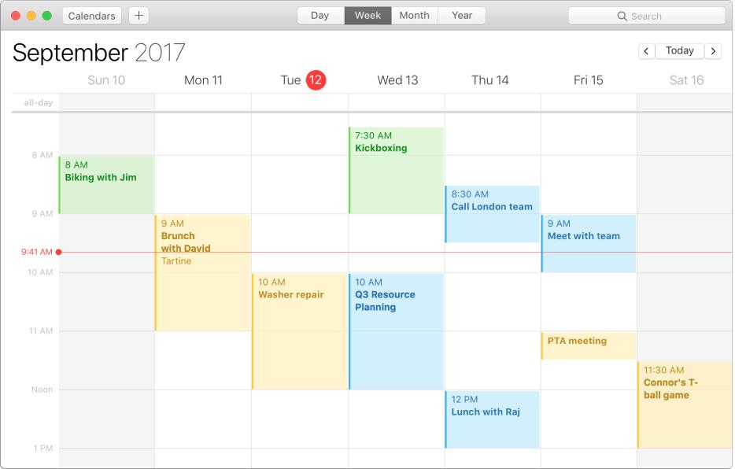
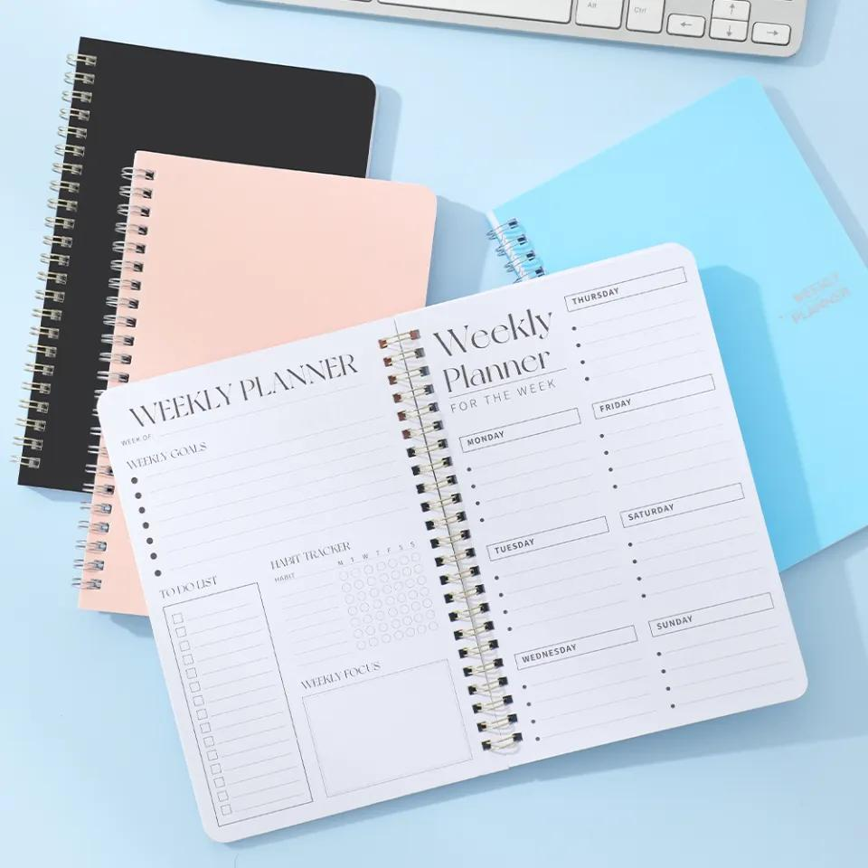
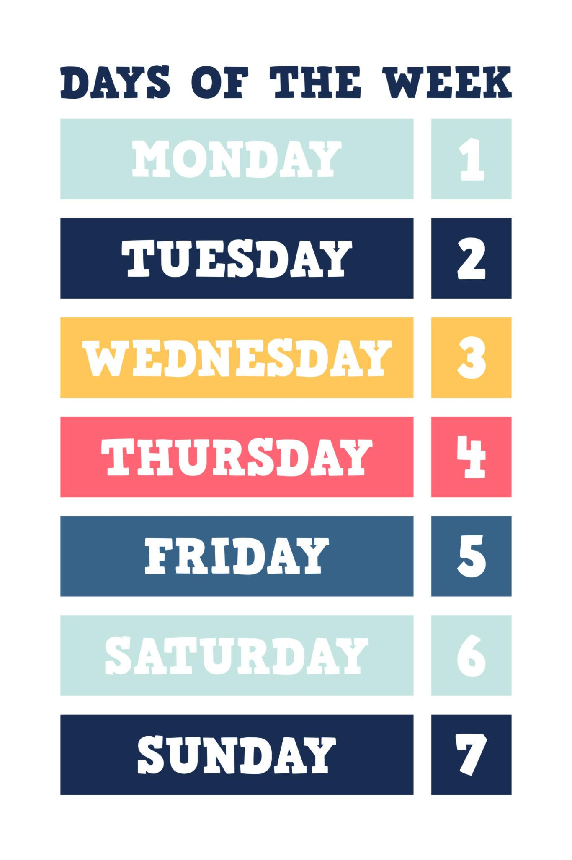
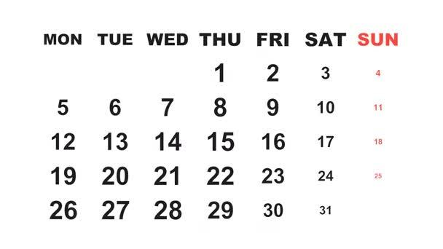
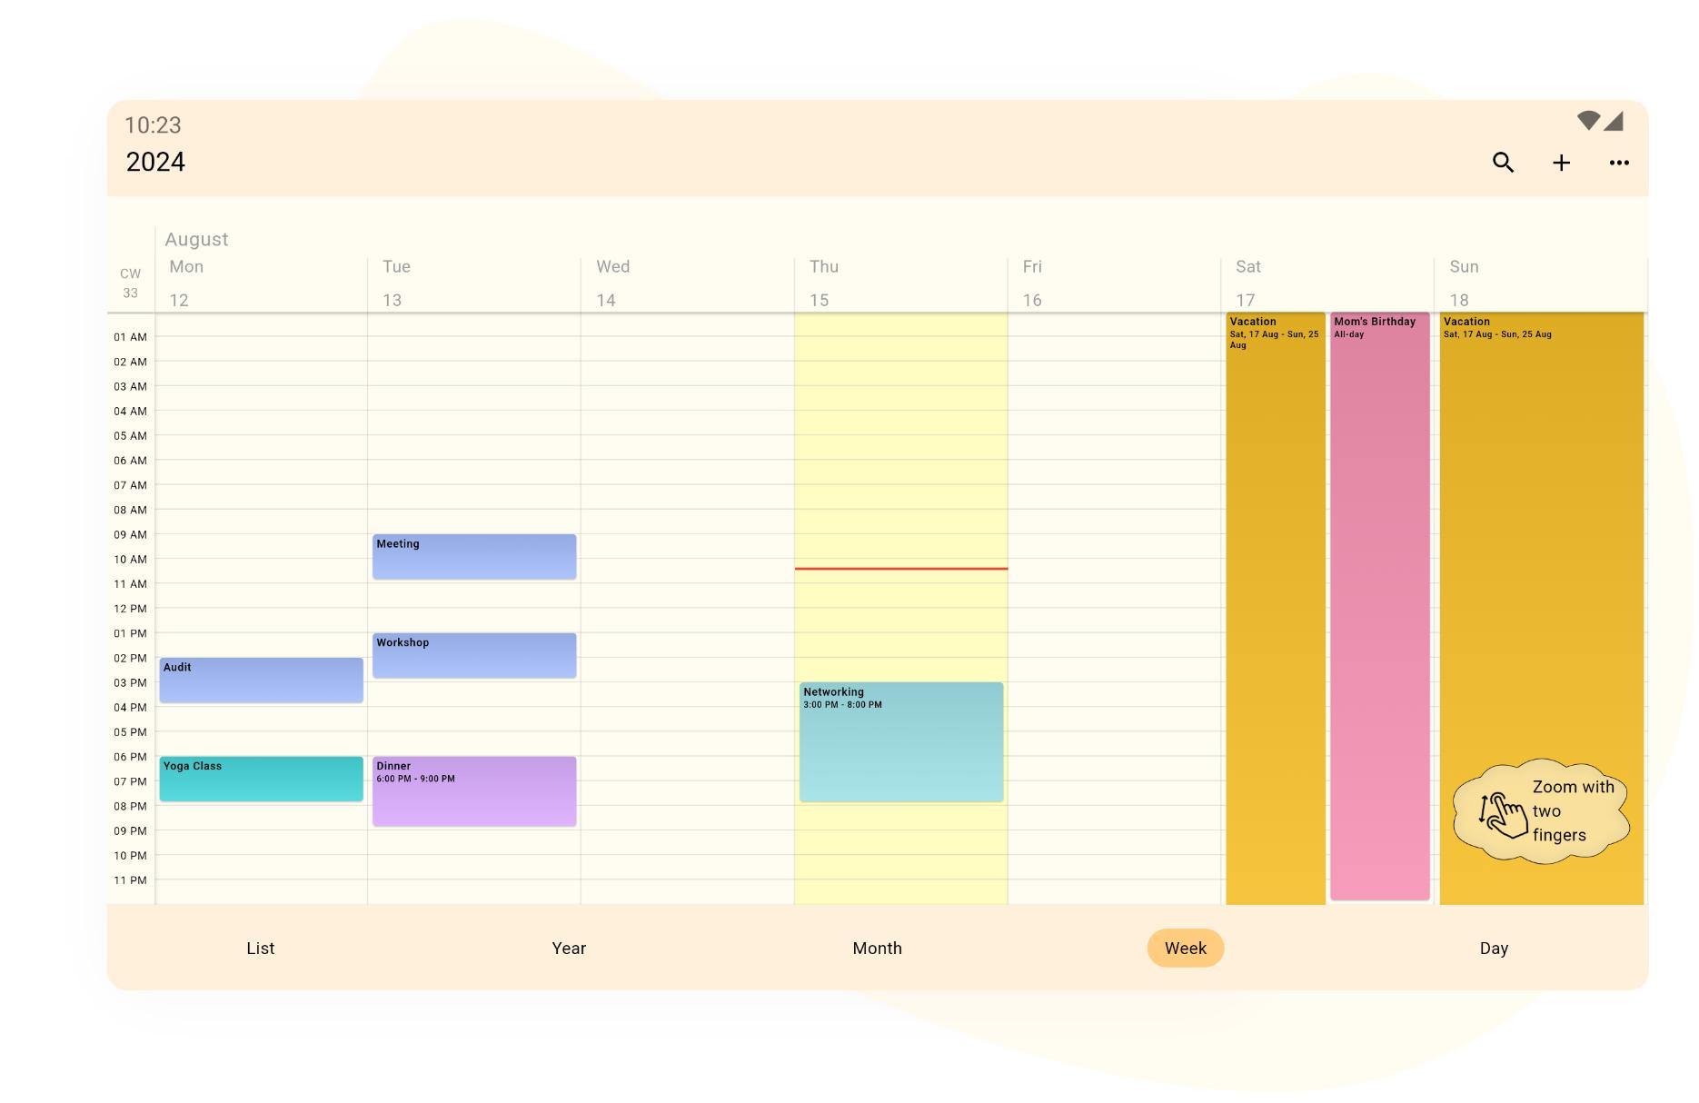
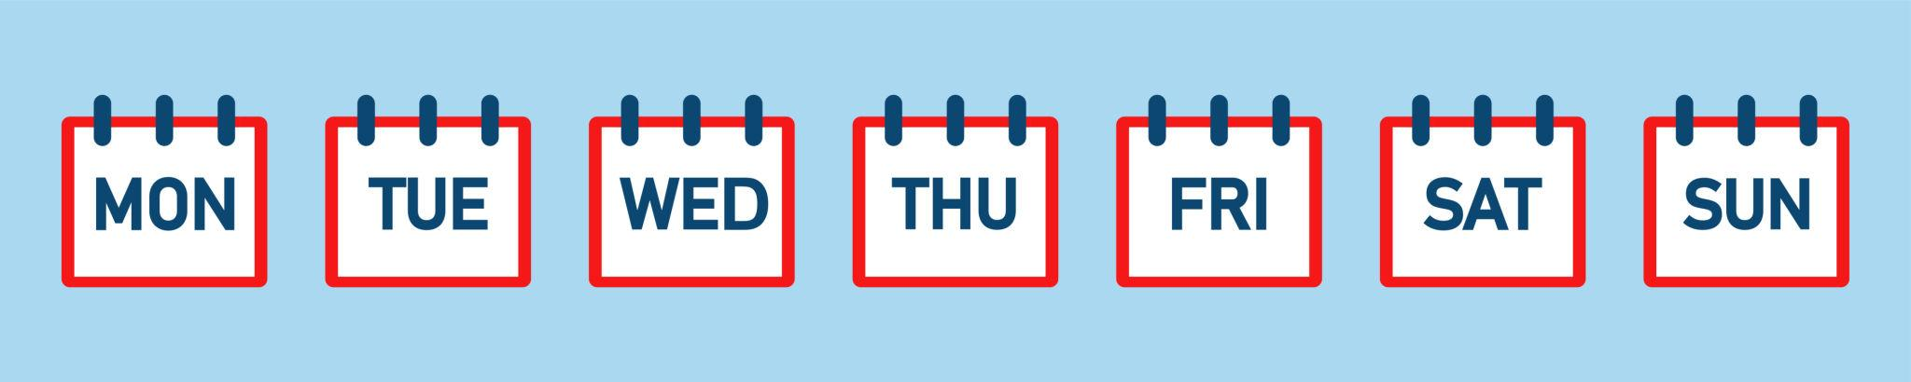
A Week is a unit of time consisting of seven consecutive days. It is one of the most widely used time intervals for organizing work, education, business, religious observances, and personal schedules.
Unlike the day, month, or year, the week is not based on an astronomical event. Instead, it is a historical and cultural convention that has become an international standard.

Definition
# Source: AI Source: Provided by: [Data Path: Persons Table -> ID Column: 1, Name_En Column: Motasem Essam] -> From: [ChatGPT] on [7/17/2026]
A Week is a period of seven consecutive days used as a standard unit of time for organizing calendars, schedules, and recurring activities.

Length of a Week
# Source: AI Source: Provided by: [Data Path: Persons Table -> ID Column: 1, Name_En Column: Motasem Essam] -> From: [ChatGPT] on [7/17/2026]
A week always contains:
- 7 days
Equivalent to:
- 168 hours
- 10,080 minutes
- 604,800 seconds

Days of the Week
# Source: AI Source: Provided by: [Data Path: Persons Table -> ID Column: 1, Name_En Column: Motasem Essam] -> From: [ChatGPT] on [7/17/2026]
In the internationally recognized order:
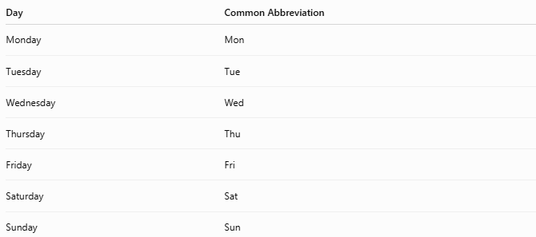
Day | Common Abbreviation
Monday | Mon
Tuesday | Tue
Wednesday | Wed
Thursday | Thu
Friday | Fri
Saturday | Sat
Sunday | Sun

First Day of the Week
# Source: AI Source: Provided by: [Data Path: Persons Table -> ID Column: 1, Name_En Column: Motasem Essam] -> From: [ChatGPT] on [7/17/2026]
The first day of the week depends on the convention used:
International Standard (ISO 8601)
- Monday is the first day of the week.
Common Calendar Convention (many countries)
- Sunday may appear as the first day on calendars.

Purpose
# Source: AI Source: Provided by: [Data Path: Persons Table -> ID Column: 1, Name_En Column: Motasem Essam] -> From: [ChatGPT] on [7/17/2026]
Weeks are used to:
- Organize work schedules.
- Plan school timetables.
- Schedule meetings.
- Track recurring events.
- Arrange transportation schedules.
- Plan personal activities.

Relationship to Other Time Units
# Source: AI Source: Provided by: [Data Path: Persons Table -> ID Column: 1, Name_En Column: Motasem Essam] -> From: [ChatGPT] on [7/17/2026]
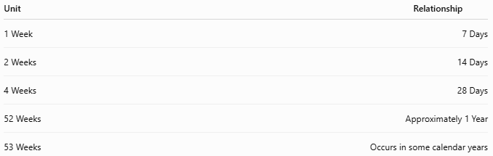
Unit | Relationship
1 Week | 7 Days
2 Weeks | 14 Days
4 Weeks | 28 Days
52 Weeks | Approximately 1 Year
53 Weeks | Occurs in some calendar years

Week Numbering
# Source: AI Source: Provided by: [Data Path: Persons Table -> ID Column: 1, Name_En Column: Motasem Essam] -> From: [ChatGPT] on [7/17/2026]
Many organizations use week numbers.
Under the ISO 8601 standard:
- Week 1 is the week containing the first Thursday of the year.
- Weeks begin on Monday.
- A year usually contains:
  - 52 weeks
  - Sometimes 53 weeks

Weekdays and Weekend
# Source: AI Source: Provided by: [Data Path: Persons Table -> ID Column: 1, Name_En Column: Motasem Essam] -> From: [ChatGPT] on [7/17/2026]
Many cultures divide the week into:
Weekdays
- Monday
- Tuesday
- Wednesday
- Thursday
- Friday
Weekend
- Saturday
- Sunday
However, weekend days vary between countries and cultures.

Applications
# Source: AI Source: Provided by: [Data Path: Persons Table -> ID Column: 1, Name_En Column: Motasem Essam] -> From: [ChatGPT] on [7/17/2026]
Weeks are used in:
- Business planning
- Education
- Payroll
- Project management
- Medical appointments
- Sports schedules
- Transportation
- Personal calendars

Advantages
# Source: AI Source: Provided by: [Data Path: Persons Table -> ID Column: 1, Name_En Column: Motasem Essam] -> From: [ChatGPT] on [7/17/2026]
Using weeks helps:
- Create regular schedules.
- Organize recurring tasks.
- Simplify planning.
- Improve time management.
- Standardize work cycles.

Common Mistakes
# Source: AI Source: Provided by: [Data Path: Persons Table -> ID Column: 1, Name_En Column: Motasem Essam] -> From: [ChatGPT] on [7/17/2026]
- Assuming every month contains exactly four weeks (most months are longer than four weeks).
- Confusing the first day of the week under different calendar conventions.
- Assuming every year has exactly 52 weeks (some years have 53 ISO weeks).

Interesting Facts
# Source: AI Source: Provided by: [Data Path: Persons Table -> ID Column: 1, Name_En Column: Motasem Essam] -> From: [ChatGPT] on [7/17/2026]
- The seven-day week has been used for thousands of years.
- It became an international standard through widespread historical, cultural, and religious adoption.
- Unlike the day, month, and year, the week is not directly based on astronomical cycles.

Key Points
# Source: AI Source: Provided by: [Data Path: Persons Table -> ID Column: 1, Name_En Column: Motasem Essam] -> From: [ChatGPT] on [7/17/2026]
- A Week consists of 7 consecutive days.
- It equals:
  - 168 hours
  - 10,080 minutes
  - 604,800 seconds
- Weeks are used worldwide for organizing work, education, business, and personal life.
- According to ISO 8601, weeks begin on Monday.
- A year contains approximately 52 weeks, with some years containing 53 weeks.

Conclusion
# Source: AI Source: Provided by: [Data Path: Persons Table -> ID Column: 1, Name_En Column: Motasem Essam] -> From: [ChatGPT] on [7/17/2026]
A Week is a universally recognized unit of time consisting of seven consecutive days. Although it is not derived from an astronomical cycle, it has become one of the most practical and widely used periods for organizing calendars, work schedules, education, business operations, and everyday activities. Its consistent seven-day structure provides a simple and effective framework for planning and managing time.

